# CS 255 System Design Document Template

This template lays out all the different sections that you need to complete for Project Two. Each section has guidance to prompt your thinking. You will need to continually reference the interview transcript as you work to make sure that you are addressing your client’s needs. There is no required length for the final document. Instead the goal is to complete each section based on what your client’s needs are. Remove this note when you are finished, and replace all bracketed text with the relevant information.

## UML Diagrams

### UML Use Case Diagram

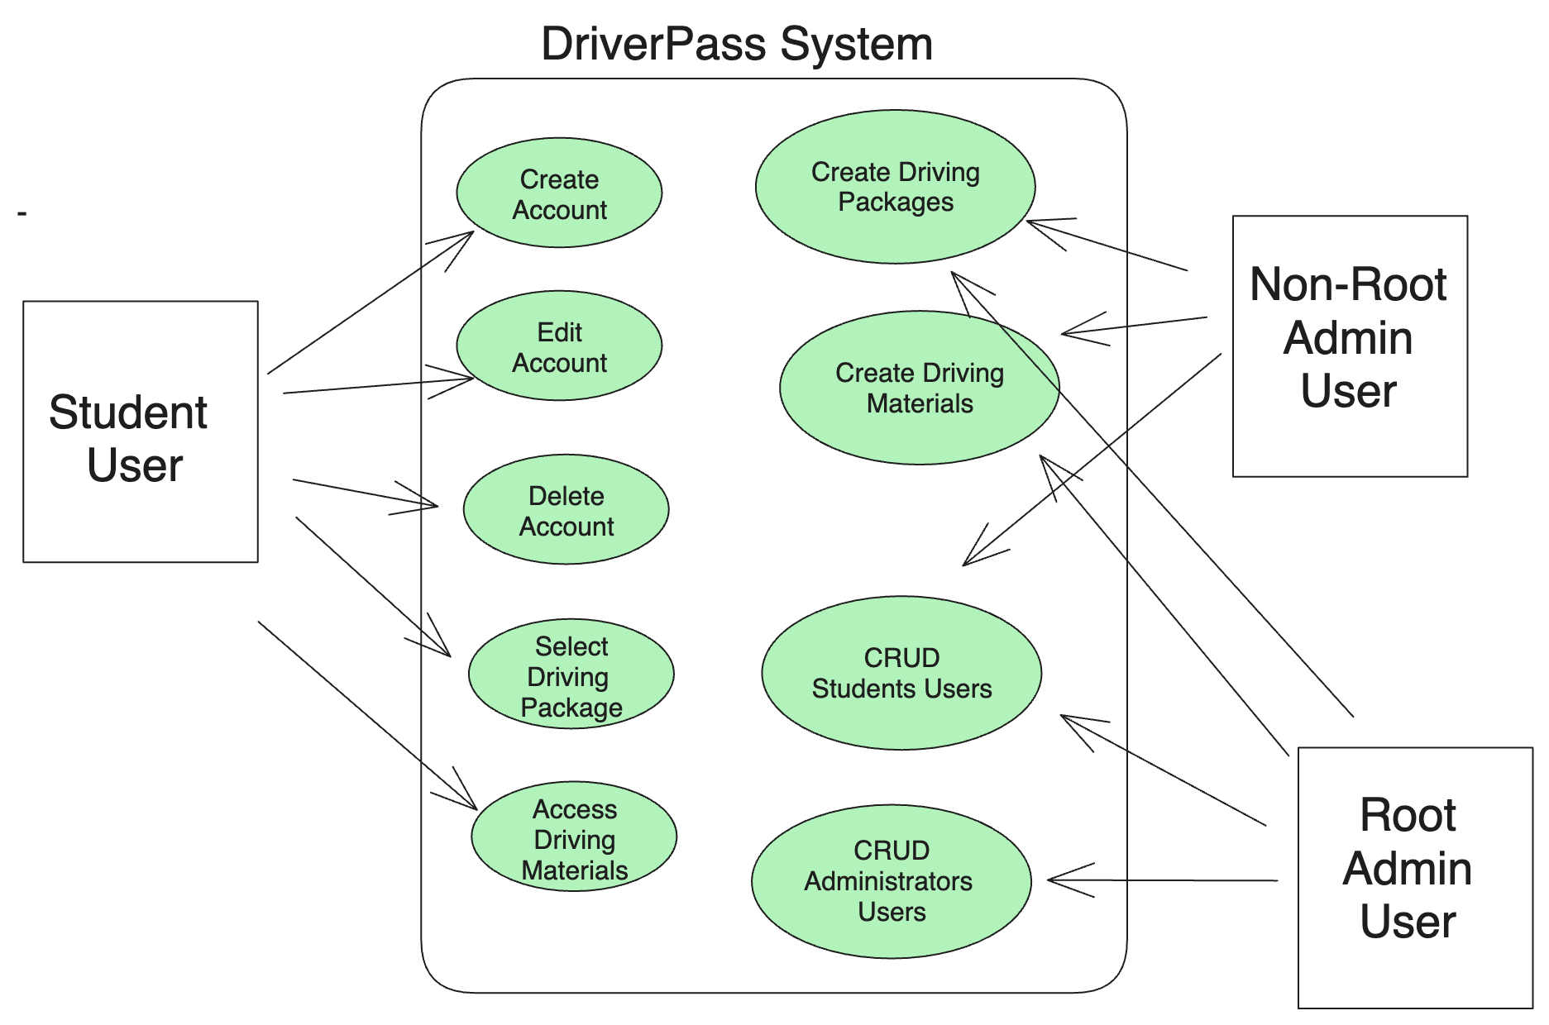

### UML Activity Diagrams

***Student UML Activity Diagram***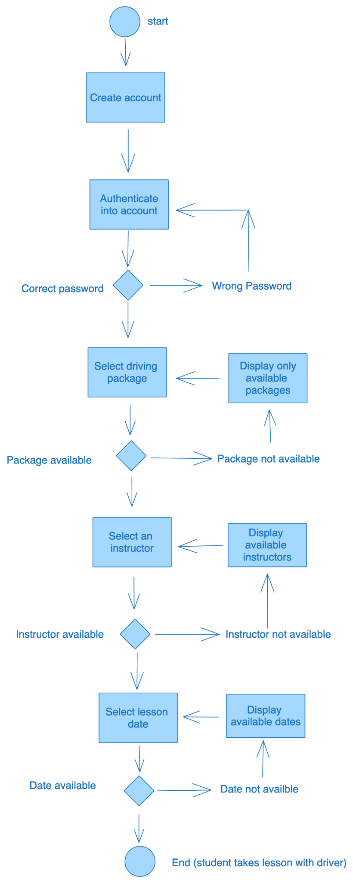

***Employee Activity Diagram***

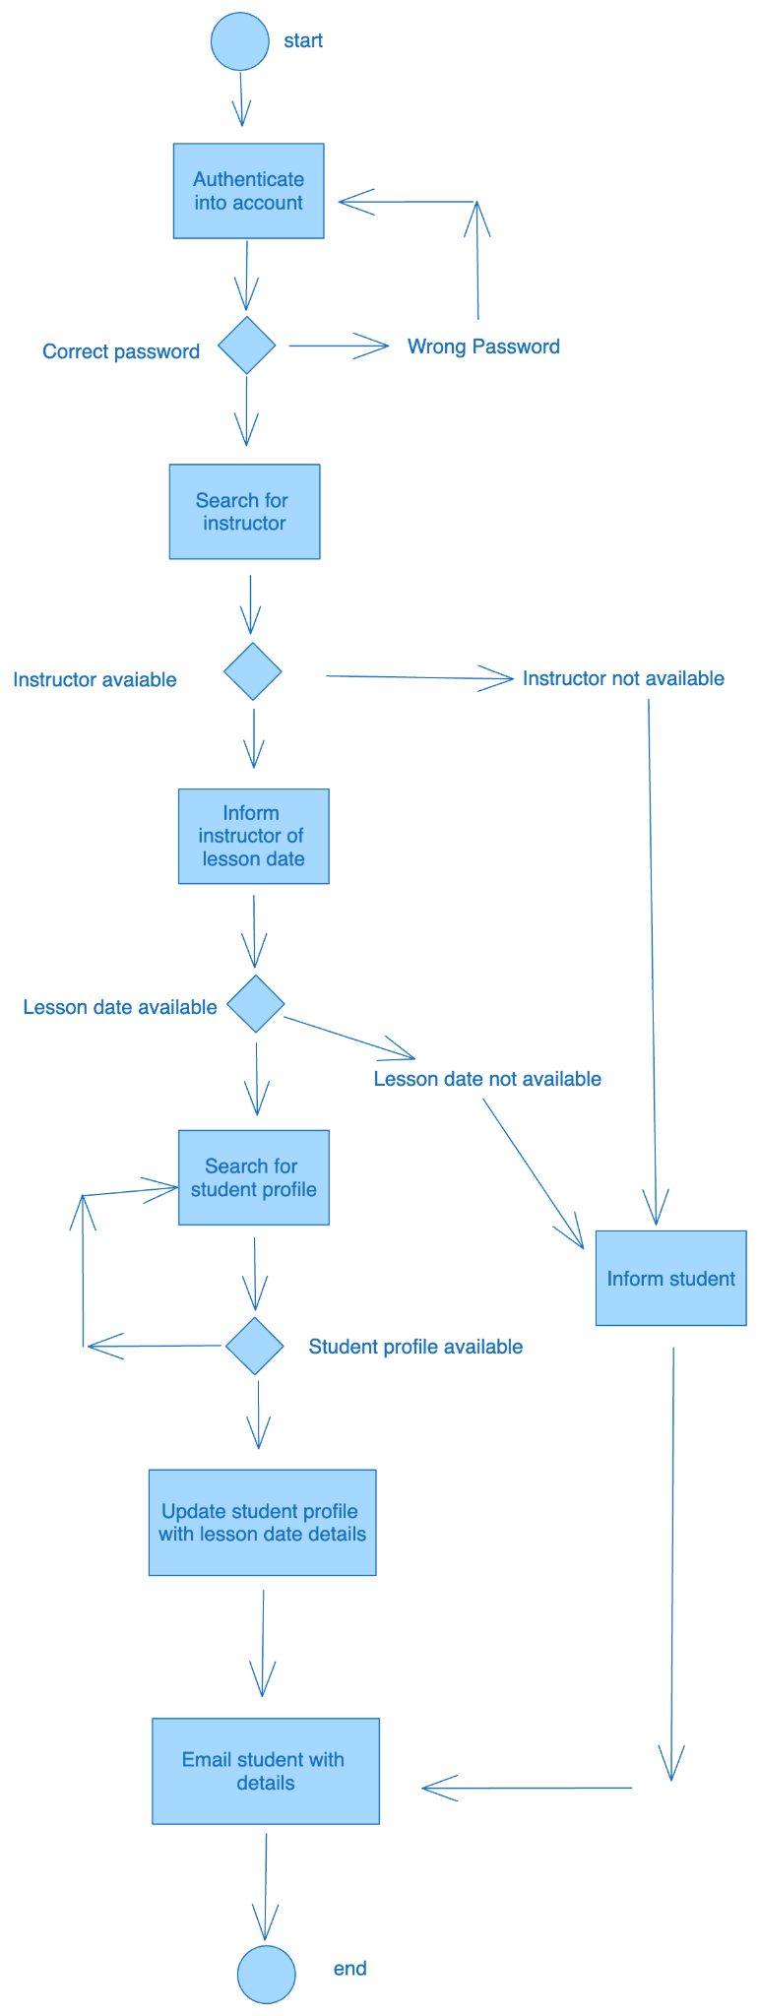

### UML Sequence Diagram

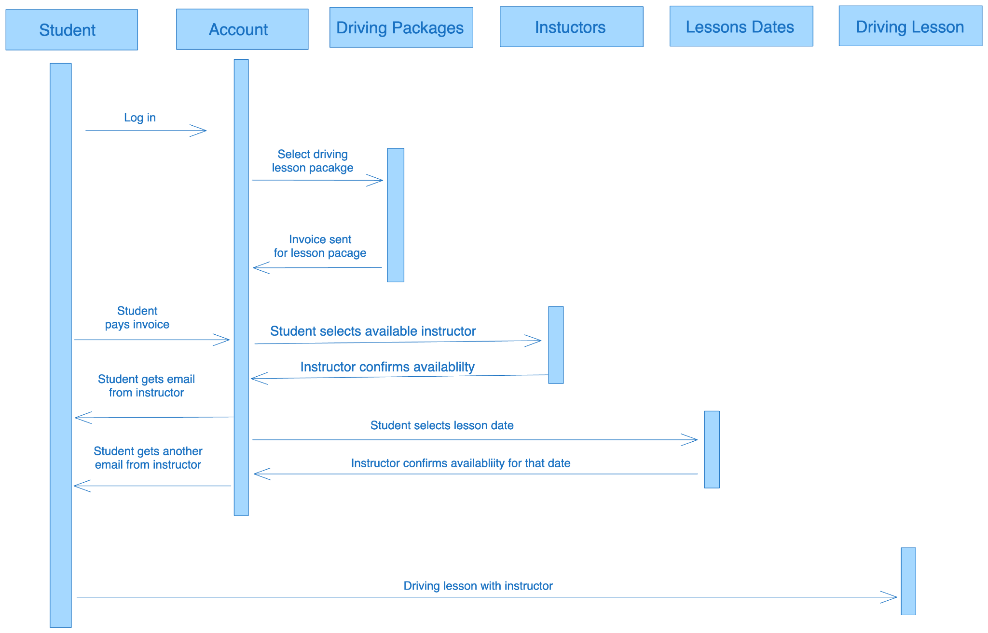

### UML Class Diagram

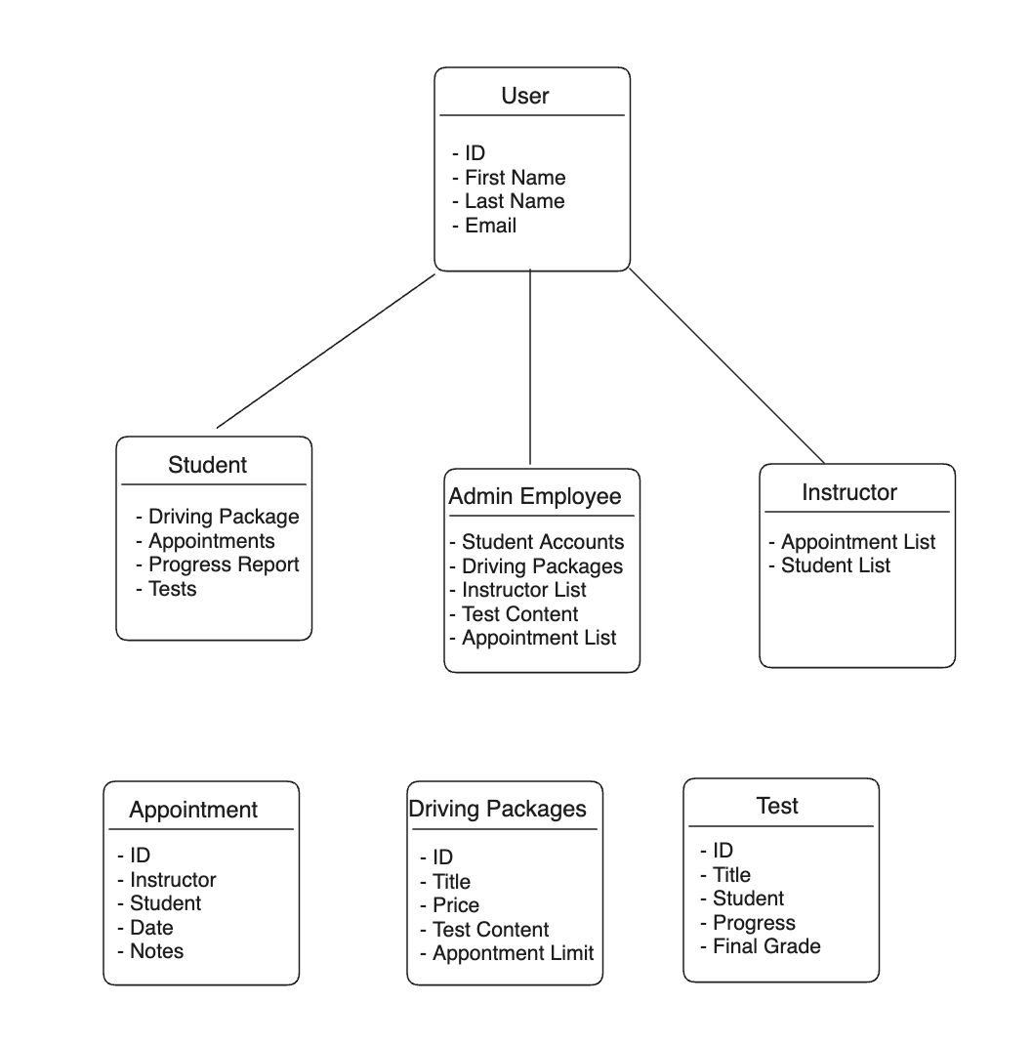

## Technical Requirements

*[Based on the diagrams you have created, describe the technical requirements of your system. These requirements should address the required hardware, software, tools, and infrastructure necessary for your system design.]*

To implement code that will cover all these UML diagrams, we would need a developer who understands a backend technology either C++ or Java and has access to a laptop with a minimum of 16gB or ram to code out the project. We would also need access to a cloud provider and database solution so we can build database models around these objects to store information about them. Overall, we would need a developer to create the project equipped with a laptop with a RAM requirement and access to the internet. From there the developer will need permissions to use CLI tools and proper infrastructure that interact with the cloud provider and push code to the production environment.